Automated Question Bank Generation System
A Project Based Learning Report Submitted in partial fulfilment of the requirements for the award of the degree

of

Bachelor of Technology
in The Department of Computer Science and Engineering
Data Structures & Algorithms

Submitted by
2510030389: Deekshith Reddy P
2510030155: Jashwanth Yadav G

Under the guidance of
____________________ (Faculty Name)



Department of Computer Science and Engineering
Koneru Lakshmaiah Education Foundation, Aziz Nagar
Aziz Nagar – 500075
OCT - 2026.
Abstract
The Automated Question Bank Generation System is a web-based application developed to automate the preparation of question banks from educational textbooks and PDF documents. The system addresses the time-consuming manual process of reading large learning resources, identifying important concepts, preparing questions, assigning difficulty, checking duplicates, organizing questions, and exporting assessment material. It combines document processing, natural language processing, question generation, similarity analysis, database storage, search, filtering, and export into one workflow.
The system accepts both digital and scanned documents. Digital PDFs are processed through PDF text extraction, while scanned documents can be processed using OCR. The extracted text is cleaned and passed through an NLP pipeline for keyword extraction and topic classification. The identified concepts are then used to generate multiple question formats, including multiple-choice questions, short-answer questions, numerical questions, and case-based questions. Each generated question is associated with metadata such as topic, type, difficulty, and quality score.
To improve the usefulness of the generated question bank, the system applies TF-IDF and cosine similarity to identify highly similar questions and reduce duplication. Questions are stored in SQLite and can be searched or filtered by topic, difficulty, type, and quality. The application also provides CSV and JSON export options and REST API endpoints for programmatic access. The final prototype demonstrates a complete end-to-end pipeline and provides a foundation for future improvements using transformer-based models, Bloom’s Taxonomy, multilingual generation, cloud deployment, LMS integration, and automatic question-paper creation.
List of Figures
Figure 1 – System Architecture of the Automated Question Bank Generation System
Figure 2 – End-to-End Question Bank Generation Workflow
Figure 3 – Question Generation and Quality-Control Pipeline
Figure 4 – Functional Testing and Result Flow

List of Tables
Table 1 – Technology Stack
Table 2 – Data Structures and Algorithms Complexity
Table 3 – Functional Testing Results
Table 4 – Input, Processing, and Output Mapping
Table 5 – Question Types and Generation Characteristics
Table 6 – Review 3 Baseline and Review 4 Enhancements
Table of Contents
Abstract
List of Figures
List of Tables
1. INTRODUCTION
1.1 Background and Motivation
1.2 Problem Statement
1.3 Research Gap
1.4 Objectives
1.5 Scope of the System
2. METHODOLOGY
2.1 System Architecture
2.2 Document Ingestion and OCR
2.3 NLP Processing and Topic Classification
2.4 Question Generation
2.5 Difficulty and Quality Estimation
2.6 Duplicate Detection
2.7 Database, Search, Filter, and Export
2.8 Technology Stack
3. EXPERIMENTS
3.1 Experimental Workflow
3.2 Data Structures and Algorithms
3.3 Complexity Analysis
3.4 Module-Level Experiments
3.5 Review 3 to Review 4 Progress
4. RESULTS
4.1 Functional Results
4.2 Testing Results
4.3 Feature Coverage
4.4 Discussion
5. CONCLUSION and FUTURE WORK
References

1. INTRODUCTION

1.1 Background and Motivation
The preparation of examination question banks is a recurring academic activity in schools, colleges, universities, and professional training environments. Teachers and instructors usually begin with textbooks, lecture notes, reference books, and PDF learning resources. They must read the material, identify important concepts, decide which concepts deserve assessment, frame questions, classify the questions, assign difficulty, remove repetitions, and finally organize the questions into a usable question bank. When the source material is large, this process becomes repetitive and time-consuming.
The Automated Question Bank Generation System is designed to reduce this manual effort by converting educational PDFs into structured question-bank content. The project combines document ingestion, OCR, natural language processing, topic classification, question generation, difficulty estimation, quality checking, duplicate detection, database storage, search, filtering, and export. Instead of treating question creation as a single operation, the system implements it as a sequence of processing stages.
The project belongs to the Data Structures & Algorithms domain and demonstrates how common data structures and algorithms can support a practical NLP-based web application. Dictionaries and hashing are used for fast keyword and topic lookup. Lists and arrays organize questions and associated metadata. Sorting supports ordering by topic, difficulty, or quality. TF-IDF and cosine similarity support similarity-based duplicate detection, while database indexes improve retrieval and filtering.

1.2 Problem Statement
Manual question-bank preparation creates several practical difficulties. Large documents require extensive reading and identification of relevant concepts. Question wording can vary from one person to another, producing inconsistent quality and difficulty levels. Repeated or near-duplicate questions may be included unintentionally. After questions are prepared, organizing them by topic and difficulty and exporting them into different formats adds further effort.
The project therefore addresses the problem of creating a single system that can accept educational PDF resources, extract and process their content, identify topics and keywords, generate multiple types of questions, estimate difficulty and quality, detect duplicates, store the final questions, and provide search, filtering, and export facilities.

1.3 Research Gap
The project presentation identifies a gap in combining the complete workflow in one application. A basic application may perform PDF extraction or simple question generation, but the final system integrates generation with topic classification, difficulty estimation, quality scoring, duplicate detection, persistent storage, advanced search, filtering, OCR, export, and REST API access. The contribution of the prototype is therefore the integration of these stages into a unified educational workflow.

1.4 Objectives
- Automate extraction of useful educational content from digital and scanned PDFs.
- Identify important keywords and classify extracted content into topics.
- Generate multiple question formats: MCQ, Short Answer, Numerical, and Case-based.
- Estimate question difficulty as Easy, Medium, or Hard and associate a quality score.
- Detect similar or duplicate questions using TF-IDF and cosine similarity.
- Store questions and metadata in SQLite for persistent retrieval.
- Provide keyword and metadata-based search and filtering.
- Export question banks in CSV and JSON formats.
- Provide REST API endpoints for programmatic access.
- Demonstrate a complete working web application with a professional dashboard.

1.5 Scope of the System
The implemented scope covers the end-to-end transformation of educational documents into an organized question bank. It includes document upload, PDF extraction, OCR support for scanned material, NLP processing, keyword extraction, topic classification, multi-type question generation, difficulty and quality estimation, duplicate filtering, database storage, search and filtering, export, and REST API access. The current prototype is focused on the functionality demonstrated in the supplied project presentation; advanced transformer-based generation, multilingual generation, cloud deployment, LMS integration, and automated paper setting are identified as future enhancements.

2. METHODOLOGY

2.1 System Architecture
The proposed system follows a sequential pipeline. The user first opens the web dashboard and uploads a textbook or PDF document. The document processing layer determines whether usable digital text is available. For digital PDFs, the system extracts text directly. For scanned PDFs, OCR is used to convert page images into machine-readable text. The resulting text is passed to the NLP pipeline.
The NLP stage performs text cleaning and normalization, extracts important keywords, and groups or classifies content into topics. The identified concepts become the basis for question generation. The generation stage produces the requested question formats and attaches metadata to each question. Difficulty estimation and quality scoring are then applied. Similarity analysis removes or flags questions that are too similar. Finally, validated questions are stored in SQLite and exposed through the dashboard, search/filter functions, export options, and REST API.
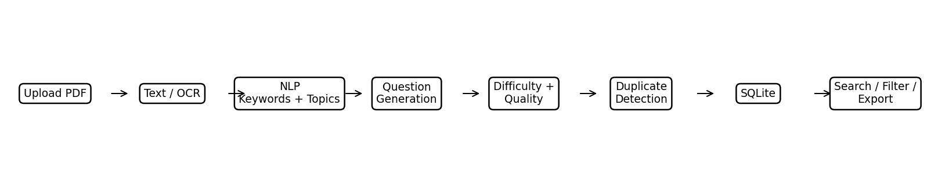
Figure 1 – System Architecture of the Automated Question Bank Generation System

2.2 Document Ingestion and OCR
The input layer is responsible for receiving the educational source. The system supports PDF and textbook-style resources and distinguishes between digital text and scanned content. PyPDF is identified in the project technology stack for PDF extraction. When the source contains scanned pages, pytesseract is used for OCR so that the content can enter the same downstream NLP pipeline.
The purpose of this stage is to create a consistent text representation for later processing. Text extraction is therefore treated as a preprocessing stage rather than as the final output. The extracted content is cleaned and normalized before keyword extraction and topic classification.

2.3 NLP Processing and Topic Classification
The NLP pipeline uses spaCy and NLTK as identified in the project stack. Text processing handles normalization and linguistic analysis so that important terms can be separated from common or uninformative words. Keyword extraction provides a compact representation of important concepts, while topic classification associates questions with meaningful subject areas.
Topic information is important because the generated question bank is intended to be searchable and filterable. A question is therefore not stored only as a sentence; it is associated with metadata that can later be used for retrieval, organization, and export.

2.4 Question Generation
The system supports four question formats. Multiple-choice questions provide an objective assessment structure. Short-answer questions require concise responses. Numerical questions are suitable for problems where a calculated result is expected. Case-based questions use a contextual situation to assess application of a concept. The user can configure the generation process by selecting the required number of questions, question types, and difficulty preference.
Question Type | Purpose | Typical Output Structure
MCQ | Objective assessment of a concept | Question + options + answer
Short Answer | Checks concise conceptual understanding | Question + expected answer
Numerical | Assesses calculation or algorithmic application | Problem + numerical result
Case-based | Assesses application in a context | Scenario + question + expected response

2.5 Difficulty and Quality Estimation
Each generated question is associated with a difficulty category: Easy, Medium, or Hard. The project also includes prototype quality scoring. These values allow instructors to review the generated bank before use and make it possible to filter the bank according to assessment requirements.
Difficulty and quality metadata are particularly useful when a large number of questions are generated. Instead of reviewing an unstructured collection, the instructor can search for questions of a desired type, topic, difficulty, or quality level.

2.6 Duplicate Detection
Duplicate detection uses TF-IDF representation and cosine similarity. TF-IDF converts question text into weighted numerical features based on the terms appearing in the collection. Cosine similarity then compares pairs of question representations. Highly similar questions can be identified and removed or filtered so that the final bank contains less repetition.
The presentation identifies pairwise duplicate detection as O(n²) in the number of questions. This is an important algorithmic consideration because similarity checking becomes more expensive as the question bank grows. The approach is therefore suitable for the prototype and provides a clear foundation for future optimization.

2.7 Database, Search, Filter, and Export
SQLite provides persistent storage for generated questions and their metadata. Indexed fields support efficient retrieval and filtering. The dashboard allows users to search using keywords and metadata and to filter by topic, difficulty, type, and quality. Once the required subset has been selected, the system can export the question bank in CSV or JSON format.

2.8 Technology Stack
Technology | Role in the System | Purpose
Python | Core implementation | Application logic and processing
Flask | Web framework | Dashboard and REST API
spaCy / NLTK | NLP | Text processing and keyword extraction
PyPDF | PDF processing | Digital PDF text extraction
pytesseract | OCR | Processing scanned PDF pages
Scikit-learn | Similarity analysis | TF-IDF and cosine similarity
SQLite | Database | Question and metadata storage
Bootstrap / JavaScript | Frontend | Dashboard and user interaction

3. EXPERIMENTS

3.1 Experimental Workflow
The experiments evaluate the system as a complete working prototype. A typical run begins with opening the dashboard and uploading a digital or scanned document. The system extracts text, performs NLP processing, identifies keywords and topics, generates the requested question types, estimates difficulty and quality, detects duplicates, stores the final questions, and makes them available for search, filtering, and export.
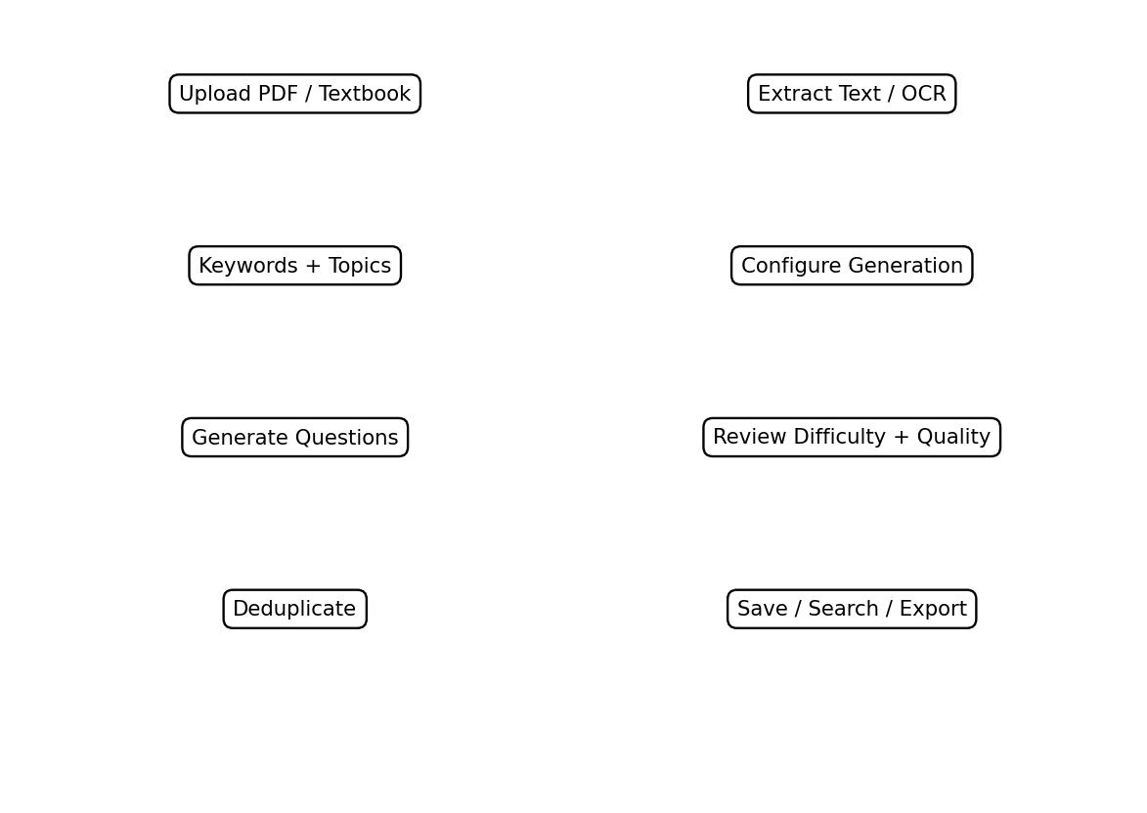
Figure 2 – End-to-End Question Bank Generation Workflow
Step 1: Open Dashboard – access the professional web interface.
Step 2: Upload PDF / Textbook – provide a digital or scanned learning resource.
Step 3: Configure Generation – select number of questions, types, and difficulty preference.
Step 4: Auto-Generate Questions – process the document and generate questions.
Step 5: Review & Score – inspect topic, keyword, difficulty, and quality information.
Step 6: Deduplicate & Save – remove similar questions and save the final bank.
Step 7: Search, Filter & Export – retrieve the required questions and export them as CSV or JSON.

3.2 Data Structures and Algorithms
The implementation demonstrates multiple Data Structures and Algorithms concepts throughout the processing pipeline. Dictionary-based hashing supports fast average-case lookup of keywords and topic information. Lists and arrays store collections of questions and metadata. Sorting organizes questions by properties such as topic, difficulty, and quality score. TF-IDF with cosine similarity supports duplicate detection, while database indexes support faster retrieval.
Technique / Structure | Use | Complexity Mentioned in Project
Hashing / Dictionary | Keyword and topic lookup | O(1) average
Lists / Arrays | Store questions, keywords, metadata | Operation dependent
Sorting | Organize by difficulty, topic, quality | O(n log n)
TF-IDF + Cosine Similarity | Duplicate detection | O(n²) pairwise
Database Indexing | Search and filtering | O(log n) indexed search
String Processing | Cleaning, normalization, comparison | Depends on text length

3.3 Complexity Analysis
Hash-based lookup is used where a direct mapping between a term and associated information is useful. Its average-case O(1) lookup makes it suitable for repeated topic or keyword access. Sorting is used when the question bank must be presented in an ordered form, with O(n log n) complexity for comparison-based sorting.
The most computationally significant stage in the current duplicate-detection design is pairwise similarity. With n questions, comparing each question against the other questions produces O(n²) pairwise comparisons. Database indexing reduces the cost of indexed retrieval and supports responsive search and filter operations. String processing occurs throughout the pipeline for cleaning, normalization, and comparison.

3.4 Module-Level Experiments
Experiment | Input | Expected Behaviour | Observed Test Status
PDF Upload & Extraction | Digital PDF | Text extracted successfully | Passed
OCR Processing | Scanned PDF | Readable text obtained for NLP stage | Passed
Keyword Extraction | Extracted document text | Important terms identified | Passed
Topic Classification | Keywords / text | Content associated with topics | Passed
Question Generation | Topics and source text | Requested question types produced | Passed
Difficulty Estimation | Generated questions | Easy/Medium/Hard assigned | Passed
Quality Scoring | Generated questions | Quality information attached | Passed
Duplicate Detection | Question collection | Similar questions filtered | Passed
Database Operations | Validated questions | Questions stored and retrieved | Passed
Search / Filter / Export | Stored question bank | Required questions retrieved and exported | Passed
REST API | Programmatic request | Endpoint provides application access | Passed

3.5 Review 3 to Review 4 Progress
The supplied presentation explicitly identifies the Review 3 baseline and the additional Review 4 functionality. The baseline consisted of a Flask web application, PDF upload and extraction, basic NLP processing, keyword extraction, topic classification, basic question generation, SQLite storage, and a basic dashboard. Review 4 extended the prototype into a more complete end-to-end application.
Review 3 Baseline | Review 4 Enhancement
Basic question generation | MCQ, Short Answer, Numerical, Case-based generation
Basic NLP processing | Difficulty and quality metadata
Basic dashboard | Professional dashboard / improved UI and UX
PDF extraction | OCR support for scanned documents
SQLite storage | Advanced search and filtering
Basic output | CSV and JSON export
Core application | REST API endpoints
No explicit similarity filtering | TF-IDF + cosine similarity duplicate detection

4. RESULTS

4.1 Functional Results
The final implementation delivers a working end-to-end workflow for converting educational PDFs into an organized question bank. The project presentation reports the prototype as fully functional. Users can upload documents, configure question generation, review generated questions and metadata, remove similar questions, save the question bank, search and filter stored questions, and export selected content.
- PDF / OCR Processing – supports digital and scanned document ingestion.
- NLP Pipeline – performs text processing, keyword extraction, and topic classification.
- Multi-Type Generation – supports MCQ, Short Answer, Numerical, and Case-based questions.
- Difficulty & Quality – provides Easy, Medium, Hard classification and prototype quality scoring.
- Duplicate Detection – applies TF-IDF and cosine similarity filtering.
- Database + Search + Export – stores questions in SQLite and supports filtering plus CSV/JSON export.
- REST API – provides programmatic access to the application.
- Professional Dashboard – provides a centralized interface for the workflow.

4.2 Testing Results
Module | Test Objective | Result
PDF Upload & Text Extraction | Verify digital PDF ingestion and text extraction | Passed
OCR | Verify scanned document processing | Passed
Topic Classification | Verify topic assignment from processed content | Passed
Question Generation | Verify requested question types are generated | Passed
Difficulty Estimation | Verify difficulty categories are assigned | Passed
Duplicate Detection | Verify similarity-based filtering | Passed
Database Operations | Verify question storage and retrieval | Passed
Search / Filter / Export | Verify retrieval and output formats | Passed
REST API Endpoints | Verify programmatic access | Passed

4.3 Feature Coverage
Feature Area | Implemented Capability | User Benefit
Input | PDF and scanned PDF | Accepts common educational resources
Processing | Text extraction and OCR | Converts documents into usable text
NLP | Keywords and topics | Improves organization and retrieval
Generation | Four question types | Supports varied assessments
Assessment metadata | Difficulty and quality | Helps instructor selection
Quality control | Duplicate detection | Reduces repetition
Storage | SQLite | Persistent question bank
Retrieval | Search and filters | Faster question selection
Output | CSV and JSON | Easy reuse and sharing
Integration | REST API | Programmatic access

4.4 Input, Processing, and Output Mapping
Stage | Input | Processing | Output
Document ingestion | PDF / textbook | Upload and validation | Source document
Text preparation | Digital/scanned pages | Extraction or OCR | Machine-readable text
NLP | Clean text | Keyword extraction and topic classification | Topics and keywords
Generation | Topics + source text | Question templates / generation logic | Candidate questions
Evaluation | Candidate questions | Difficulty and quality estimation | Scored questions
Deduplication | Question set | TF-IDF + cosine similarity | Filtered question set
Storage | Validated questions | SQLite insert/indexing | Persistent bank
Retrieval | User query/filter | Indexed search | Selected questions
Export | Selected questions | CSV/JSON serialization | Exported question bank

4.5 Discussion
The results show that the project has progressed beyond a basic question-generation prototype. The important outcome is the integration of multiple stages into one usable workflow. The system is not limited to producing question text; it also provides classification, assessment metadata, similarity-based quality control, persistence, retrieval, and export.
The prototype also demonstrates the relevance of Data Structures & Algorithms to an applied NLP system. Hash lookup, sorting, pairwise similarity, indexing, and string processing are not isolated academic exercises; they directly support the responsiveness and organization of the application. The complexity analysis highlights where the system may require optimization if the size of the question bank increases substantially.
The supplied testing results report all listed modules as passed. These results establish functional completion of the implemented prototype. They should not be interpreted as a statistical accuracy benchmark for question quality because the project presentation does not provide a numerical dataset-based evaluation of generation accuracy. Future work can therefore add systematic human evaluation, larger test sets, and quantitative quality metrics.

5. CONCLUSION and FUTURE WORK

5.1 Conclusion
The Automated Question Bank Generation System successfully demonstrates an end-to-end method for converting educational PDFs into an organized, searchable, and exportable question bank. The project addresses the practical problem of manual question preparation by combining document ingestion, OCR, NLP processing, topic classification, question generation, difficulty estimation, quality scoring, duplicate detection, database storage, search, filtering, and export.
The system provides four question formats—MCQ, Short Answer, Numerical, and Case-based—and associates generated questions with useful metadata. The use of TF-IDF and cosine similarity introduces an explicit duplicate-detection stage, while SQLite provides persistent storage. Search and filtering make the resulting bank easier to use, and CSV/JSON export supports reuse outside the application.
From a Data Structures & Algorithms perspective, the project demonstrates hashing, lists and arrays, sorting, pairwise similarity analysis, string processing, and indexed database retrieval. The complexity analysis also identifies duplicate detection as an O(n²) component, making it an important target for future optimization as the number of generated questions increases.

5.2 Future Work

Transformer Models
T5 and BERT-based methods can be explored for more advanced question generation and improved contextual understanding.

Bloom’s Taxonomy
Questions can be classified according to cognitive levels so that instructors can build assessments with a controlled distribution of learning objectives.

Multi-Language Support
The system can be extended to generate and manage questions in multiple languages.

Cloud Deployment
AWS or Azure deployment can make the service accessible at larger scale and support integration with learning management systems.

Automatic Question Papers
Rule-based or intelligent paper generation can select questions according to topic, difficulty, type, and required distribution.

User Authentication
User accounts and access control can be added for secure multi-user operation and personalized question banks.

5.3 Overall Contribution
The main contribution of the project is a unified prototype that brings document processing and question-bank management into a single workflow. It provides a practical demonstration of how NLP, web development, database systems, and Data Structures & Algorithms can be combined to automate an academic task while retaining instructor-oriented controls such as search, filtering, review, and export.

References
- [1] Automated Question Bank Generation System, Review 4 – Final Implementation, project presentation supplied for the documentation.
- [2] PBL Final Documentation Template, Project Based Learning report template supplied for formatting and section structure.
- [3] Flask Documentation, web framework identified in the project technology stack.
- [4] spaCy Documentation and NLTK Documentation, NLP libraries identified in the project technology stack.
- [5] Scikit-learn Documentation, TF-IDF and cosine similarity methods used for duplicate detection.
- [6] PyPDF Documentation, PDF extraction component identified in the project technology stack.
- [7] pytesseract Documentation, OCR component identified in the project technology stack.
- [8] SQLite Documentation, database technology identified for question-bank storage and indexed retrieval.
- [9] Bootstrap Documentation, frontend framework identified in the project technology stack.
- [10] Python Documentation, programming language used for the application and processing pipeline.

IMPLEMENTATION SUMMARY

System Completion Checklist
Component | Completion Status | Description
Web Dashboard | Completed | Professional interface for the question-bank workflow
PDF Upload | Completed | Accepts textbook/PDF resources
PDF Text Extraction | Completed | Processes digital PDF content
OCR | Completed | Processes scanned documents
Keyword Extraction | Completed | Identifies important terms
Topic Classification | Completed | Associates content with topics
Question Generation | Completed | Generates four supported question types
Difficulty Estimation | Completed | Easy, Medium, and Hard
Quality Scoring | Completed | Prototype quality assessment
Duplicate Detection | Completed | TF-IDF + cosine similarity
SQLite Storage | Completed | Persistent question-bank storage
Search & Filtering | Completed | Keyword and metadata-based retrieval
CSV / JSON Export | Completed | Multiple output formats
REST API | Completed | Programmatic access endpoints

End-to-End Processing Summary
The completed workflow can be summarized as: Upload → Extract/OCR → Clean Text → Extract Keywords → Classify Topics → Generate Questions → Estimate Difficulty → Score Quality → Detect Duplicates → Store in SQLite → Search/Filter → Export. This sequence represents the central implementation demonstrated by the project presentation.
The completed documentation describes the project at the level supported by the supplied presentation and PBL template. The report distinguishes implemented prototype features from future enhancements so that the final document remains consistent with the project evidence.

